Inquiry Based Labs
Physical Setting in Chemistry

Amy Gaon
Leonie Rubin
8/23/2016

Lab: Introduction to the Chemistry Lab

Purpose:
- To learn about safety in the lab.
- To locate safety equipment and explain their function.
- To review fire drill procedures.
- To identify and learn the function of equipment in your lab station. Your teacher may include additional material.

Materials: Equipment in your lab stations

Procedure:
Part A: With your lab partner research lab safety. Make a new safety contract consisting of 20 safety rules. Submit the contract along with your signature.
Part B: With your lab partner diagram the room. Make sure to show the location of each piece of safety equipment: safety goggles, fire blanket, fire extinguisher, eye wash station and shower. Include in your diagram the location of the emergency window and doors.
Part C: Create a table showing the function of each piece of safety equipment.
Part D: Discuss with your lab partner what you would do in case of a fire. Include your exit plan for this room.
Part E: Identify each piece of lab equipment in your lab station as well as those provided by your teacher. Create a data table including the name of the piece of equipment, diagram, and its function.

Data:
Part A: Signed safety contract.
Part B: Room diagram. Remember to use a key or label.
Part C: Table of the safety equipment and function
Part D: Fire exit strategy
Part E: Table of Equipment

Conclusion:
For each scenario:
- Describe 5 safety rules you should use.
- Include a list of equipment that would be used.
- Anticipate what could go wrong and how you would best handle the situation.
Scenario 1: Add 10 grams of a salt to water.
Scenario 2: Heat the salt/water to remove the water.
Scenario 3: Dilute an acid.
Scenario4: Decompose a solid.

Lab: Measurement Challenge

Purpose:
- Review metric measurements
- Take measurements using significant figures
- Set up an accurate data table
- Perform calculations using significant figures
- Calculate the density of a regular solid, irregular solid and a liquid
- Percent error

Materials: metric ruler electronic balance graduated cylinder metal block 1 pennies water

Procedure:
Part A: With your lab partner write the steps you would use to find the density of water.
Part B: With your lab partner write the steps you would use to find the density of a metal block.
Part C: With your lab partner write the steps you would use to find the density of a penny.

Data:
For Parts A, B and C create three separate data tables. (Note: measurements recorded for each part may be different) Make sure you include all measurements taken using significant figures.

Calculation and Analysis of Data:
- Calculate the density of the water, metal block and the penny. Use the rules of significant figures in all calculations.\
- Using the internet research the accepted value of all three substances.
- Using your experimental values calculate the percent error.

Conclusion:
- Discuss and compare the methods used to calculate the density of all three substances.
- State the values you calculated for the density of each substance and discuss the accuracy of your experimental results.
- Error analysis. (Note: include reasons for your positive or negative percent errors.
Lab: Chemical Spill Clean-up

Purpose:
- Become familiar with laboratory techniques that are used to separate mixtures.
- Become familiar with laboratory equipment.

Materials: A mixture will be supplied by your teacher. All other equipment should be determined by you and your lab partner. Include a list of the materials you will be needed.

Procedure:
Problem scenario: You are employed by a waste disposal company that has been hired to clean up a chemical spill resulting from a train derailment. The derailment occurred over a dry sandy riverbed. During the clean-up of the accident a chemical called ipodium was collected along with some sand and metal fragments of the train. You are the chemist assigned to design a method for handling the separation of the mixture. You need to recover the ipodium along with the sand and metal fragments for their proper disposal. You should submit the following to your employer.
- Mass of the original sample used.
- A detailed three part procedure used to separate the metal, sand and ipodium.
- All three components should be massed after they are separated and returned upon separation to your employer.

Data: Your data table should include the following: mass of the original sample, mass of the metal, mass of the sand and the ipodium.

Analysis of Data: Compare the masses of the original sample with the combined masses of the recovered material.

Conclusion:
- Discuss the methods used for the separation of the mixture.
- Were you successful? Explain by providing a detailed error analysis.
- If you had time to repeat this process what would you do differently?

Lab: A New Element is Found

Purpose: To experimentally determine the isotopic mass of the new element Chemium.

Materials: navy beans kidney beans lima beans electronic balance

Procedure: Today you will be John Dalton the discoverer of a new element—Ch. Your job is to determine its average isotopic mass. The element Ch is found in nature to consist of three isotopes based on their different masses. Using a 50 atom sample of the three isotopes and a percent abundance provided by your instructor, you will devise a procedure to determine the average isotopic mass of the new element. Do a second trial with a 100 atom sample.

Data: Include all data pertaining to each isotope.

Analysis of Data: Calculate the average isotopic mass for each trial.

Conclusion:
- Discuss the method used to calculate average atomic mass. Include the equation that you used.
- Compare your results from trial 1 and 2. Why are they similar or different?
- Compare your results with your classmates for trial 1. Why are they similar or different?

Lab: Decomposition of Sodium bicarbonate

Purpose:
- To determine the mass of sodium bicarbonate needed to form a target mass of sodium carbonate.
- To compare your results from the experiment with those obtained using stoichiometry.

Materials: Sodium bicarbonate electronic balance Bunsen burner crucible (no lid) clay triangle ring stand

Procedure:
- Write a balanced equation (including the phases) for the decomposition of sodium bicarbonate into sodium carbonate, carbon dioxide and water. Include this equation above the data table.
- You will be given a target mass of sodium carbonate that will be produced from the decomposition of sodium bicarbonate. Determine using stoichiometry the theoretical amount of sodium bicarbonate needed. Include this in the analysis of data section.
- Using the theoretical value for the sodium bicarbonate devise a procedure to determine the experimental amount of sodium carbonate produced.
- Compare the experimental amount of sodium carbonate produced with the target mass you were given.

Data:
- Write the balanced equation.
- Create a data table including the grams and moles of sodium bicarbonate you used and the experimental grams and moles of sodium carbonate produced.

Calculations and Analysis of Data:
- Show your work for the stoichiometry used to determine the initial amount of sodium bicarbonate needed.
- Calculate the percent error for the grams of sodium carbonate produced.
- Calculate the percent yield for the measured product.

Conclusion:
Compare the theoretical value for the sodium carbonate with your experimental value. ? Provide an error analysis explaining any inconsistencies.

Lab: Which metal is more active?

Purpose: Using your knowledge of redox reactions you will develop a metal activity series.

Materials: Metals (zinc, copper, magnesium and aluminum)
.25M Nitrate solutions containing each metal
Spot plates
1M Hydrochloric acid

Procedure: With your lab partner and the materials provided develop a safe procedure that you can use to create an activity series consisting of the four metals provided. Your procedure should include a Part A and a Part B. (One involving the acid solution and the other the nitrate solutions)

Data: Create two data tables showing the results of each test performed in an organized fashion.

Analysis of Data: Write the molecular, ionic and net ionic equation for each reaction that occurred. If no reaction occurred just include the reactants and for the products indicate no reaction took place. (Write NR) From your equations and your data table results rank the four metals from most active to least active.

Conclusion: Compare your results to the activity series on table J. Were all your results consistent with what they should be? Provide an error analysis explaining any inconsistencies. What do all the reactions that took place have in common?

Lab: Elemental Madness

Purpose: To determine the trends for ionization energy and atomic radius as one proceeds across a period and down a row.

Materials: periodic table

Procedure: Using the following tournament rules determine the winner of each round. In the event of a tie the element with the larger atomic mass always wins.
- Round 1: Research and record the date of discovery of each element. In each bracket, the element that was discovered earlier in its free form wins and proceeds to the second round. Assign a discovery date of “0” that has been known since ancient times.
- Round 2: Compare and record the ionization energy for the elements in each bracket. The element with the higher ionization energy is the winner and advances to the Sweet Sixteen.
- Round 3: (Sweet Sixteen) Compare and record the group numbers (1-18) for the elements. The winner is the element with the larger group number.
- Round 4: Compare and record the atomic radius for each element. The winner is the element with the larger atomic radius and advances to the Final Four.
- Final Four: Solve the following riddles to determine the semi finalist.
- This “salt maker” is also a rainmaker when its silver salt is scattered into clouds.
- Once a sedative and cure for nervous tension, the ion of this element is now a trite or common place expression.
- Finals: It’s often said that there is no ____ in team, but it is the winner in this competition.

Data: Record your values on the spreadsheet provided and determine the winner for each bracket.

Analysis of Data:
- Define ionization energy. Discuss and explain the trend in both a period and a group.
- Define atomic radius. Discuss and explain the trend in both a period and a group.

Conclusion: Would your results be different if you were to use the electronegativity values instead of ionization energy in round two? Explain (Include a definition for electronegativity along with an explanation of their periodic trend.) What is the relationship between atomic radius, ionization energy and electronegativity? Explain.

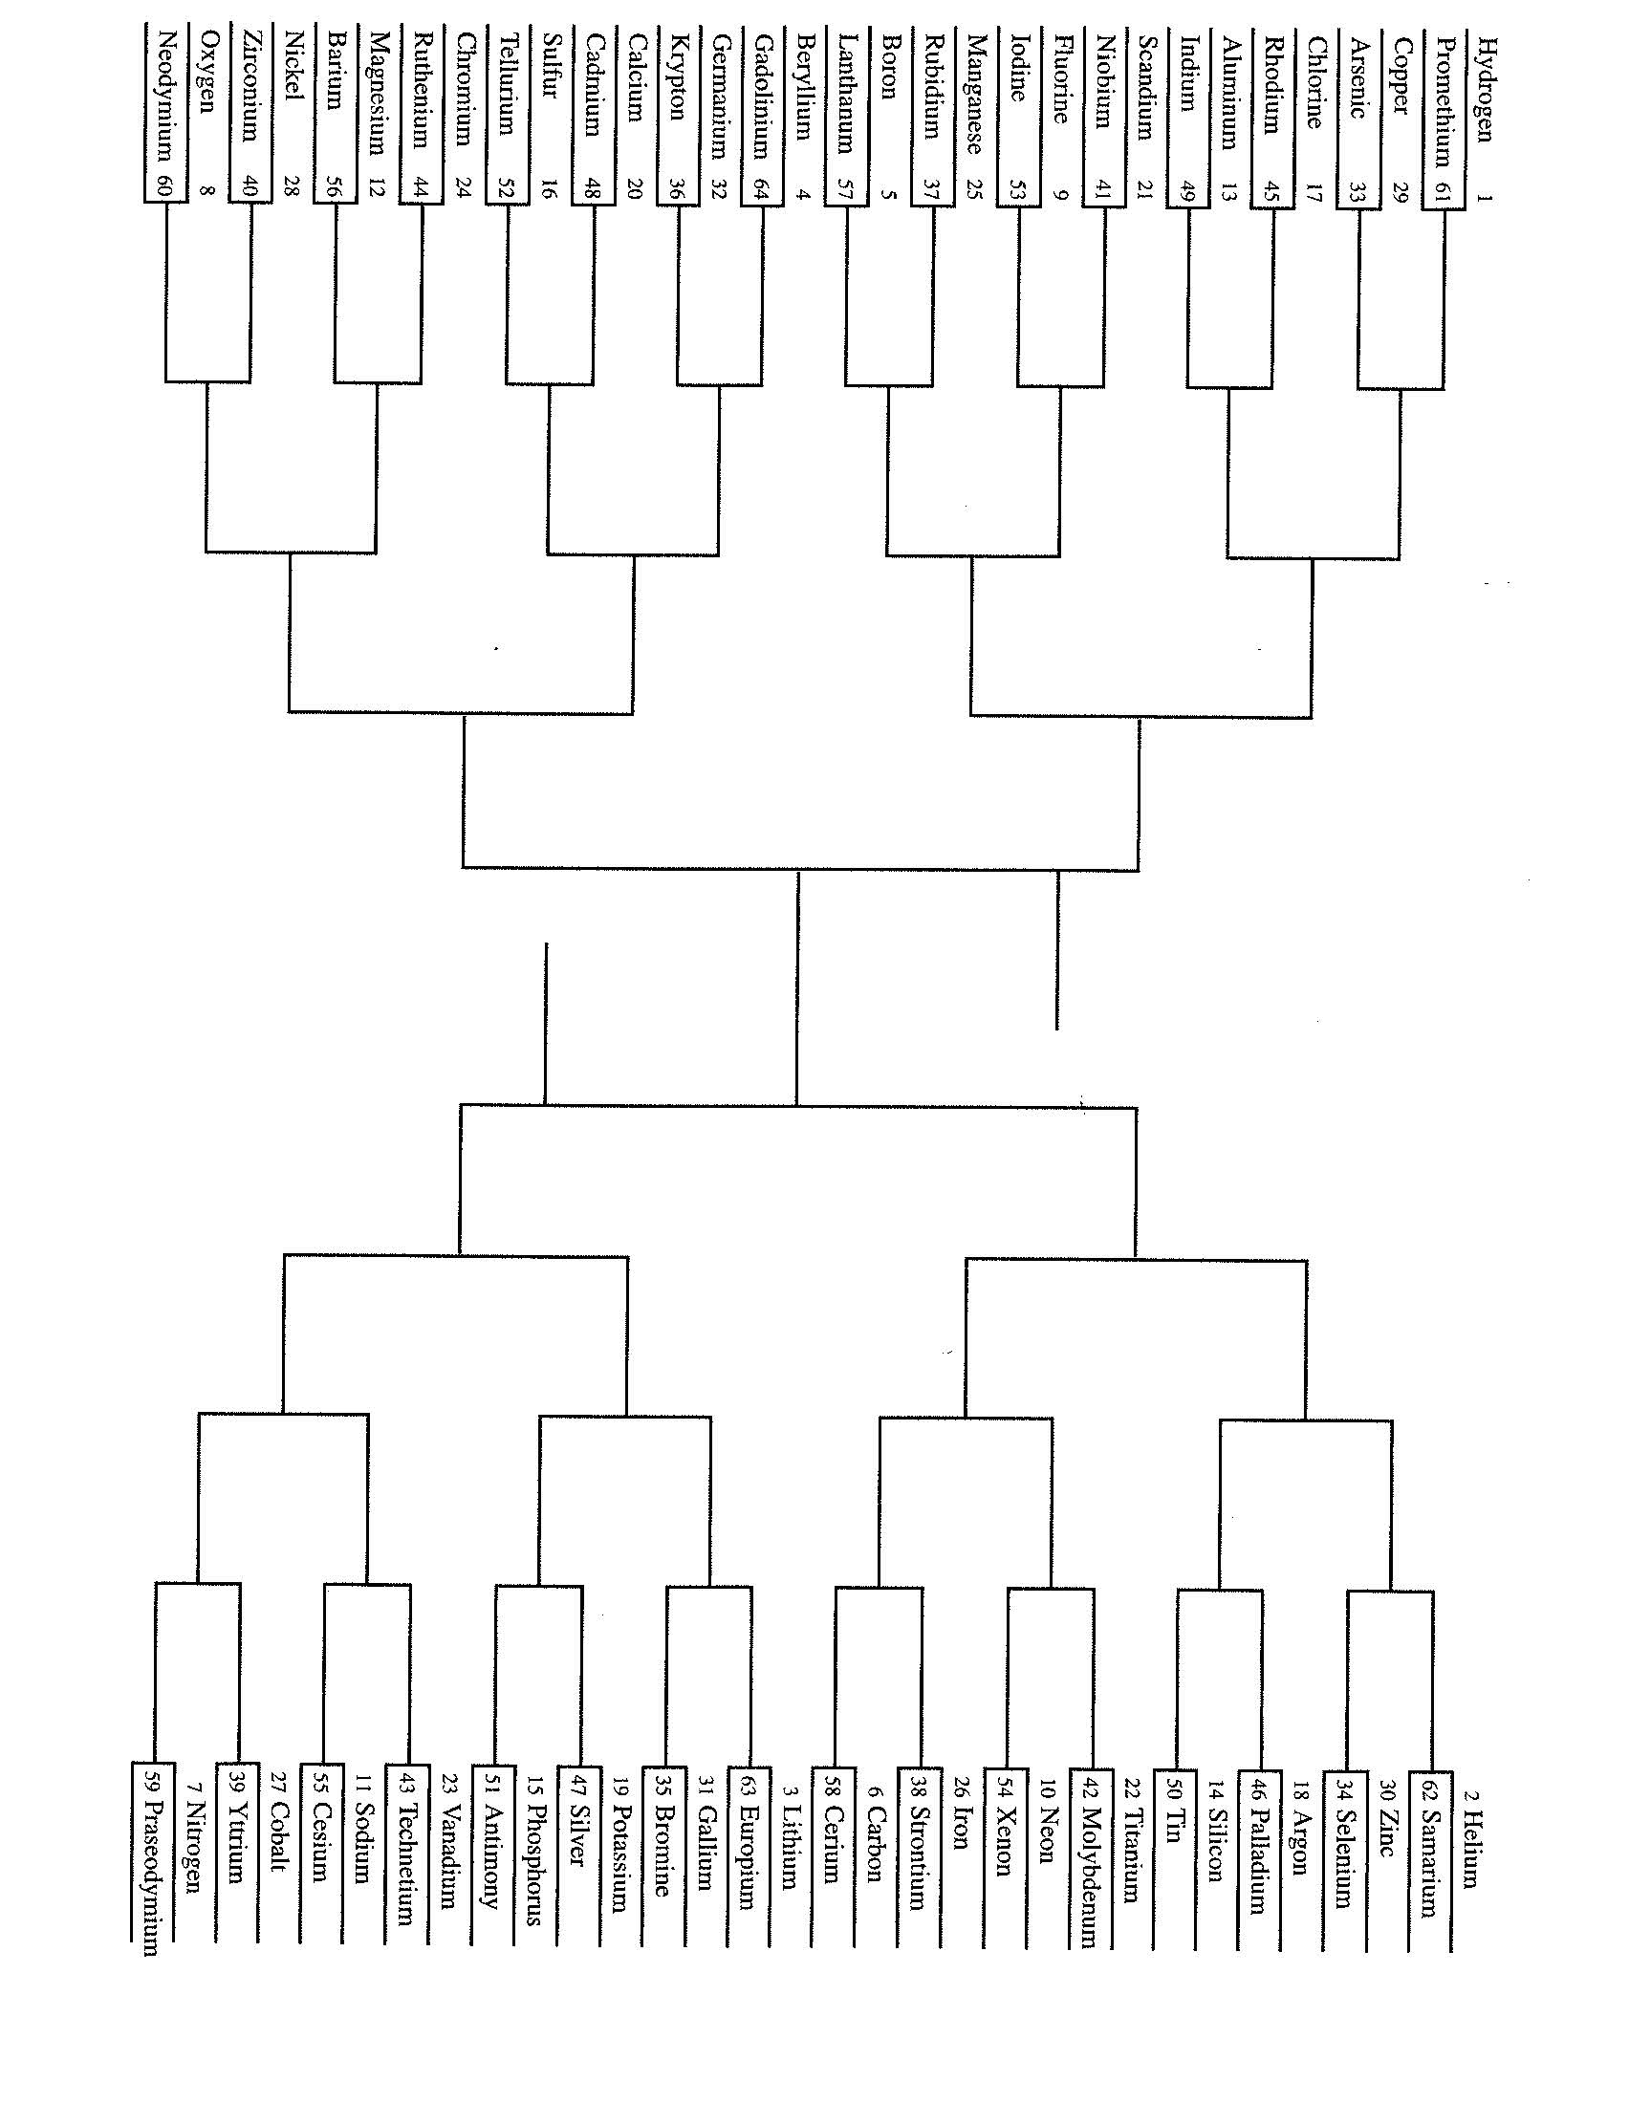

Lab: What type of bond am I?

Purpose: Some properties may be useful to predict the bond type of various substances. Given 5 unknown substances you will use these properties to determine if they have an ionic or covalent bond.

Materials: 5 unknown liquids or solids provided by your teacher
Conductivity apparatus spot plates

Procedure: Begin by filling the wells in the spot plate with each solid or liquid. If you have a solid fill a second well by making a solution. With your lab partner develop a procedure used to identify the bond type.

Data: Develop a data table showing the results of each test you preformed.

Analysis of Data: Using your results predict the bond type of each unknown.

Conclusion:
- From your experimental results make a table showing a comparison of the properties used to differentiate an ionic from a covalent bond. You must include a minimum of four properties.
- For each unknown predict if the melting point would be high or low. Explain how you came to this conclusion.

Lab: How Sweet it is!!!

Purpose:
- To create three different molar solutions for a beverage made from a powder.
- To express the concentrations in terms of percent by mass and parts per million. (ppm)

Materials: powdered drink mix (lemonade, ice tea, etc)
beakers graduated cylinders balance

Procedure: With your lab partner develop a procedure to create 100 ml solutions of varying concentrations. (.1M, .2M and .4M) Assume the powder is sucrose and you are not using 100 ml of water.

Data: Create a data table showing the mass of solute and the volume of water used to create each molarity.

Calculations and Analysis of Data: For each molarity create a table showing your calculation for each of the following:
- Moles of solute
- Exact molarity of each solution. (watch significant figures)
- Percent by mass
- Parts per million

Conclusion: Compare the relative colors produced by the varying solution concentrations. Identify the solute and the solvent in the solution made. Compare the three different methods used to express concentration. Include when you use just the solvent versus the solution in your calculations. What would be the benefit of using each method.

Lab: Analysis of unknown household materials

Purpose: To be able to use a variety of chemical and physical tests to identify five unknown household items...

Materials: .5 grams of each unknown
Alka seltzer (mixture of citric acid and sodium bicarbonate)
Citric acid
Washing soda (sodium carbonate)
Chalk (calcium carbonate)
Ammonia (ammonium hydroxide)
Spot plates phenolphthalein vinegar

Procedure: With your lab partner devise a procedure to identify the unknown solids using qualitative analysis. Using your knowledge of solubility and acid/base chemistry, along with the materials provided, to develop a step-by step method used to identify solids A through E.

Data: Create a data table indicating the results from each test you preformed.

Analysis of Data: Identify the five unknown solids.

Conclusion: Develop a flow chart that incorporates the steps used to analyze your unknowns along with the predicted results for each compound.

